TASK1

**Create the following topology and run ospf**

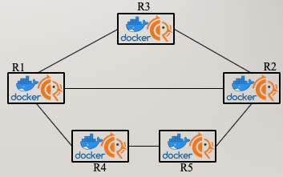

**And then, for each container, show:**

**\* ospf neighbors**

**\* ospf routes**

**\* ip routes**

**1.    Please attach the topology of your network (including Hosts/FRR router’s IP address, bridge’s network address)**

**2.    Please attach the screenshots of OSPF neighbor on each FRR routers**

**3.    Please attach the screenshots of OSPF route on each FRR routers**

FRR1:

OSPF neighbors

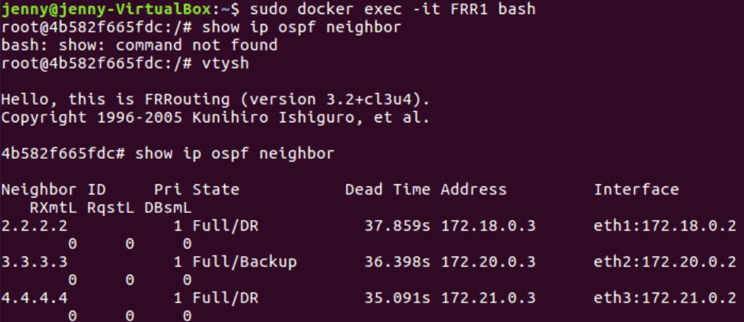

ospf routes

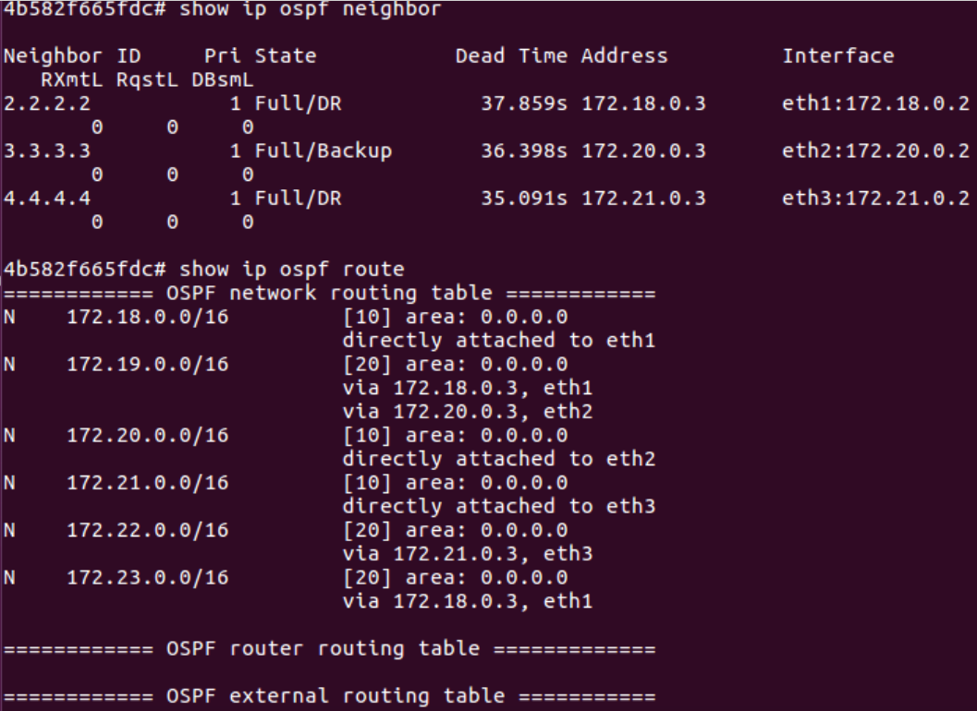

ip routes:

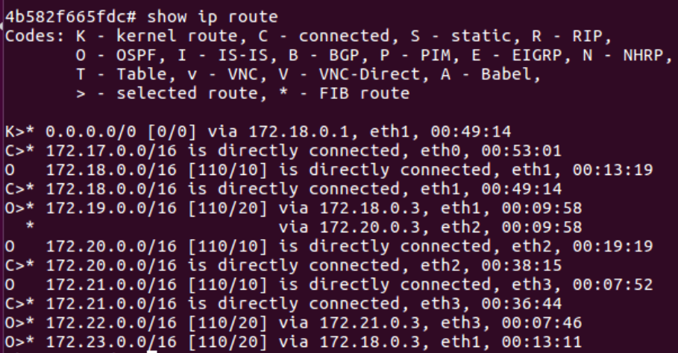

FRR2:

OSPF neighbors:

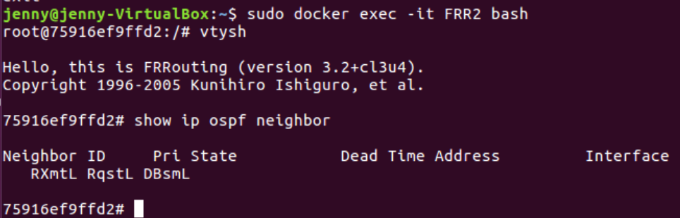

ospf routes:

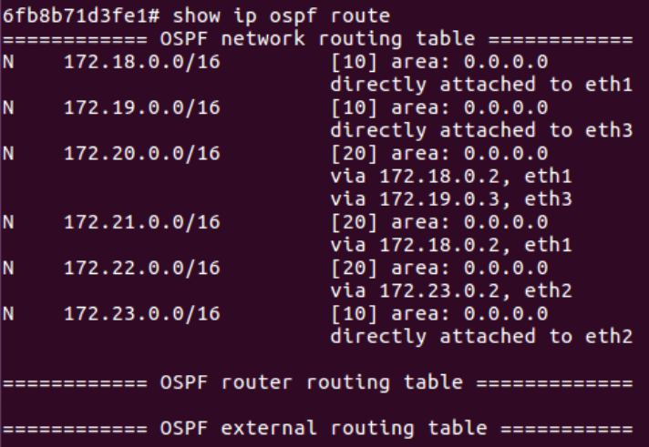

ip route:

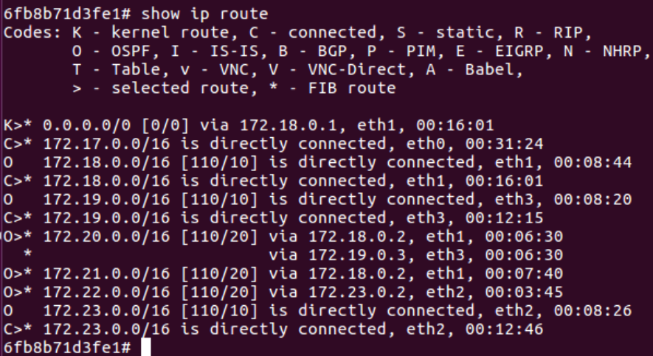

FRR3:

ospf neighbors

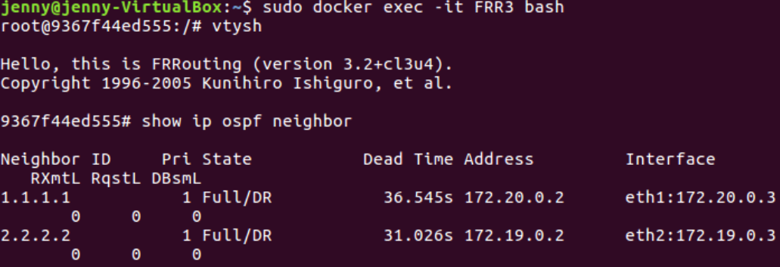

ospf routes:

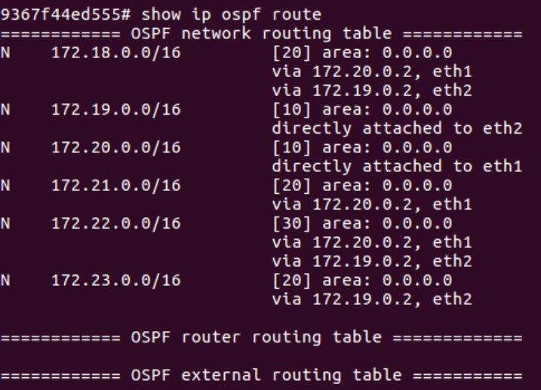

ip route:

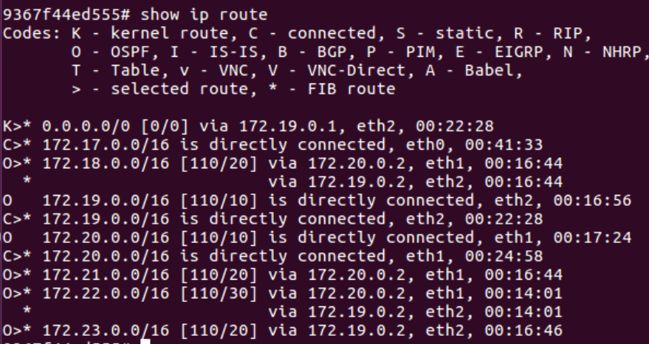

FRR4:

ospf neighbors

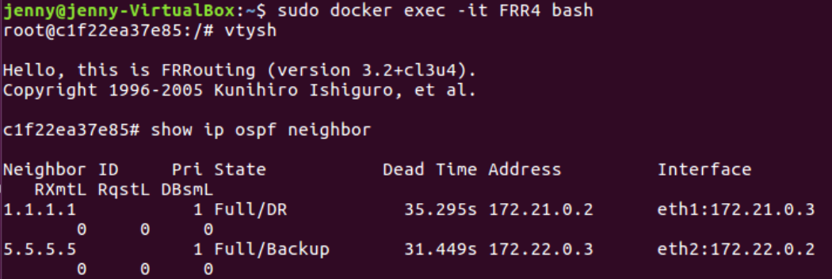

ospf routes:

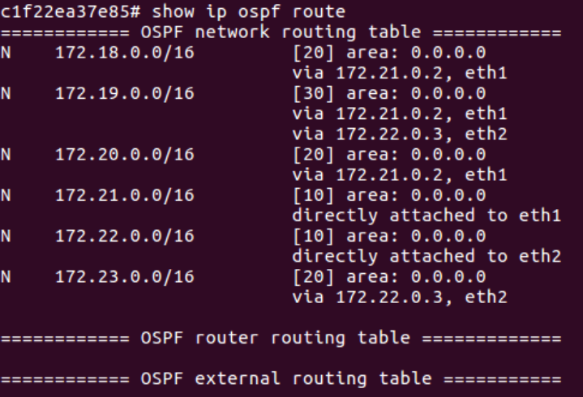

ip routes:

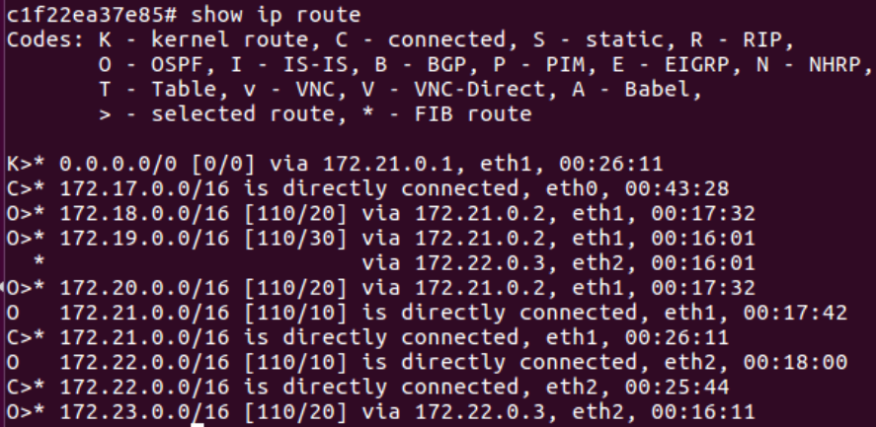

FRR5:

ospf neighbors

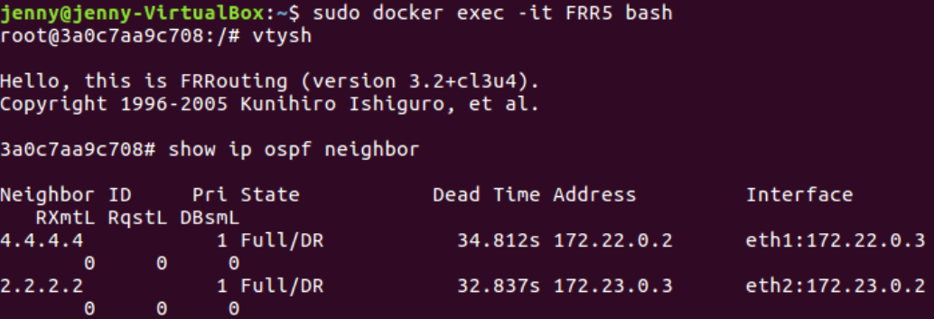

ospf routes:

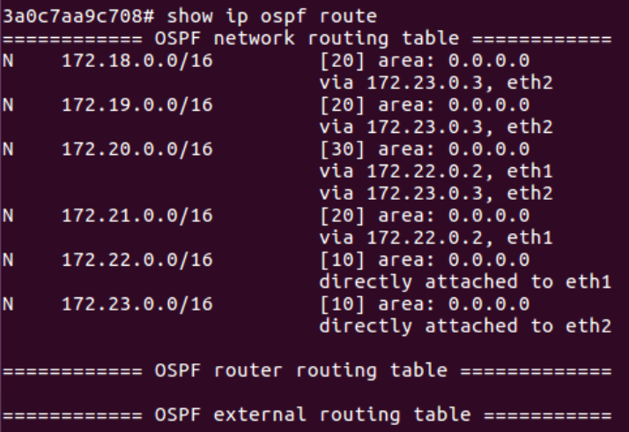

ip routes:

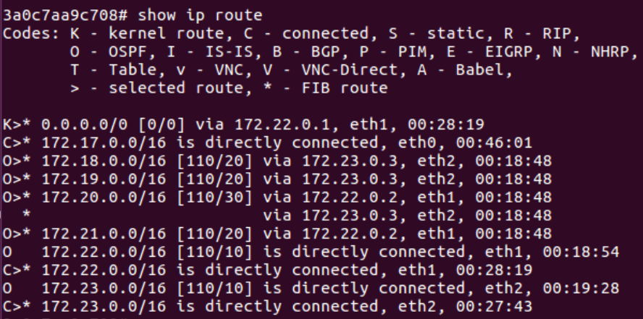

R1 ping R2

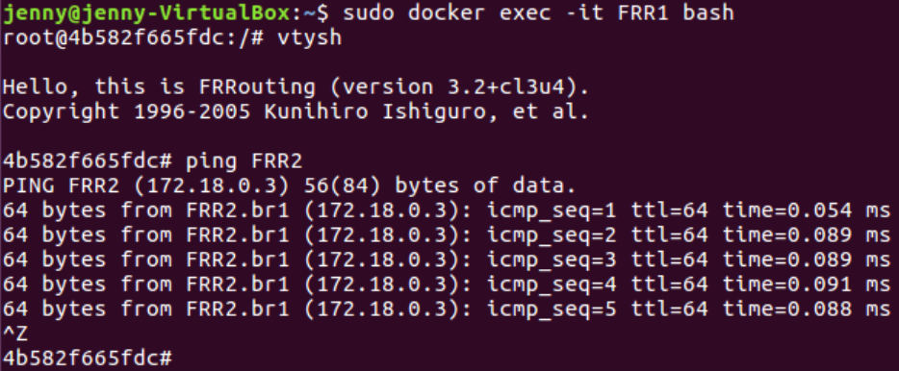

R4 ping R2

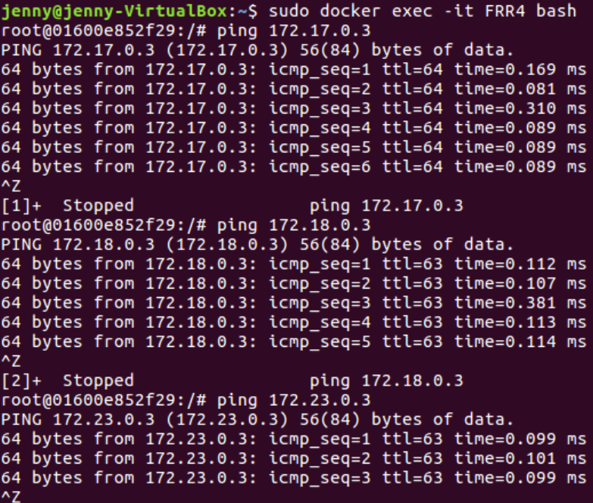

TASK2

**1.    Please attach the topology of your network (including Hosts/FRR router’s IP address, bridge’s network address)**

**2.    Please attach the screenshots of OSPF neighbor on each FRR routers**

**3.    Please attach the screenshots of OSPF route on each FRR routers**

FRR1:

ospf neighbors

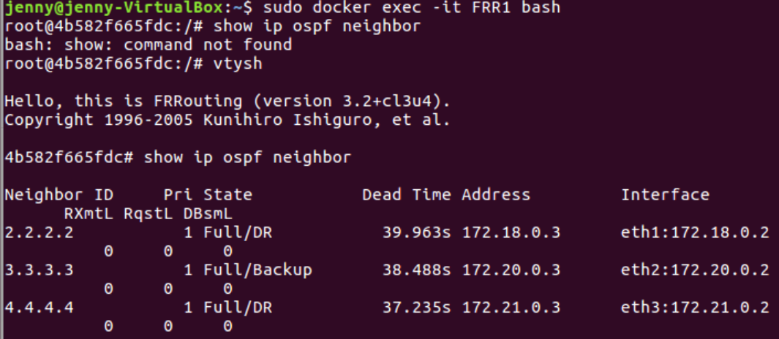

ospf routes

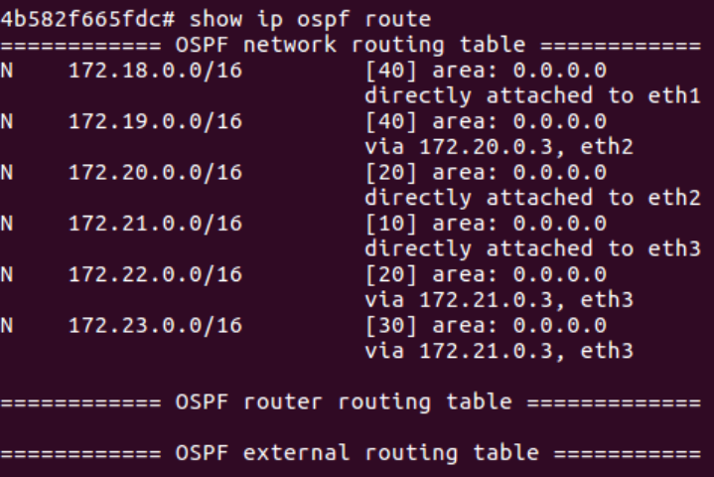

ip routes:

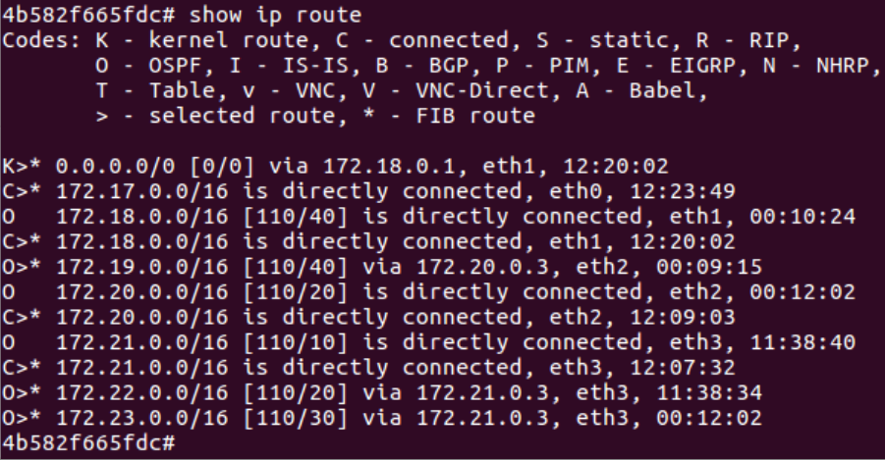

FRR2:

ospf neighbors:

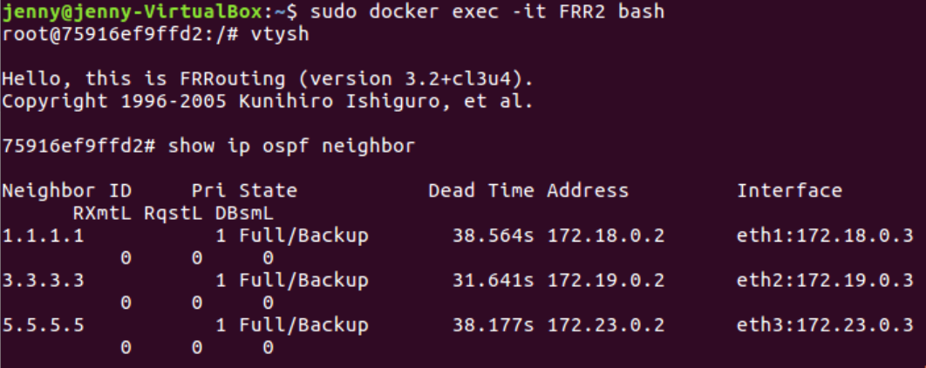

ospf routes:

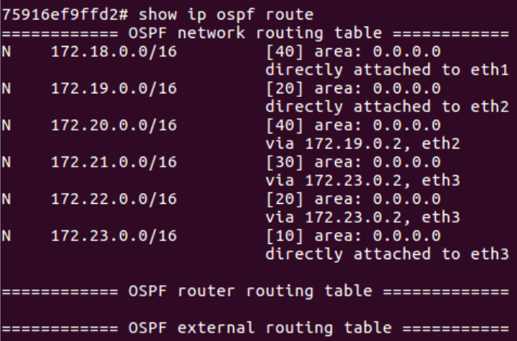

ip routes:

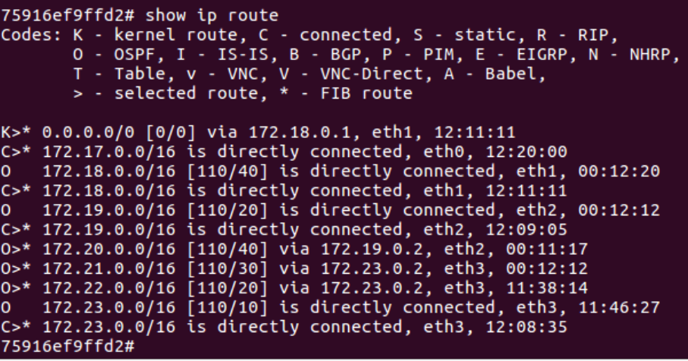

FRR3:

ospf neighbor:

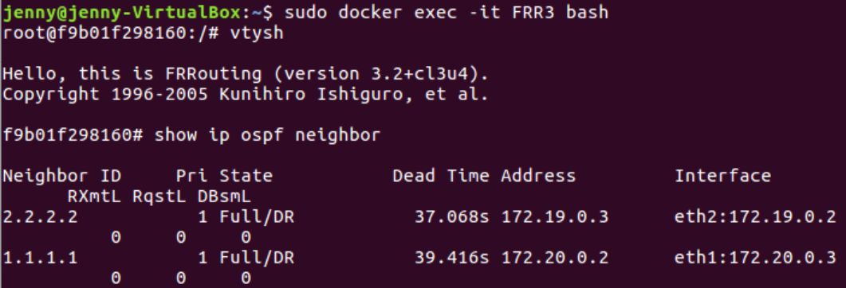

ospf routes:

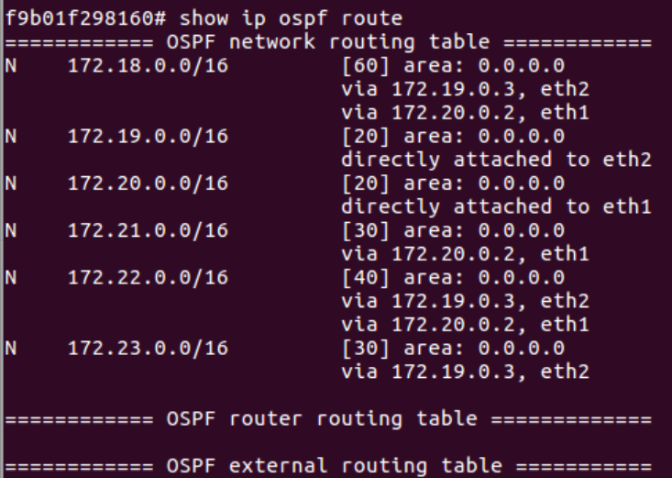

ip routes:

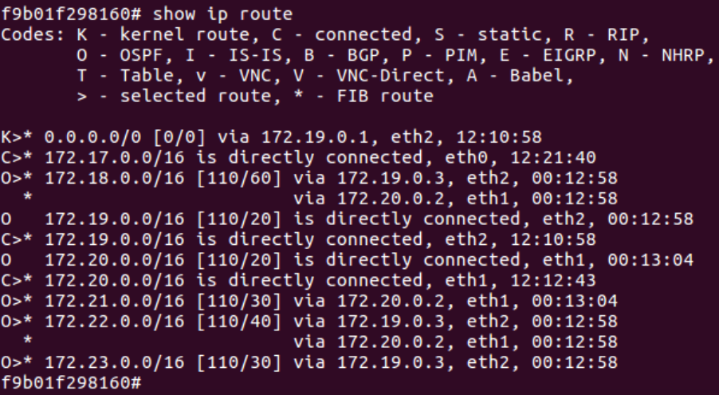

FRR4

ospf neighbor:

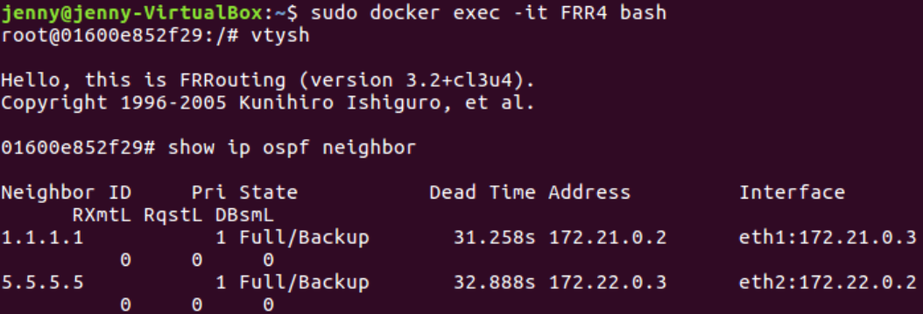

ospf routes:

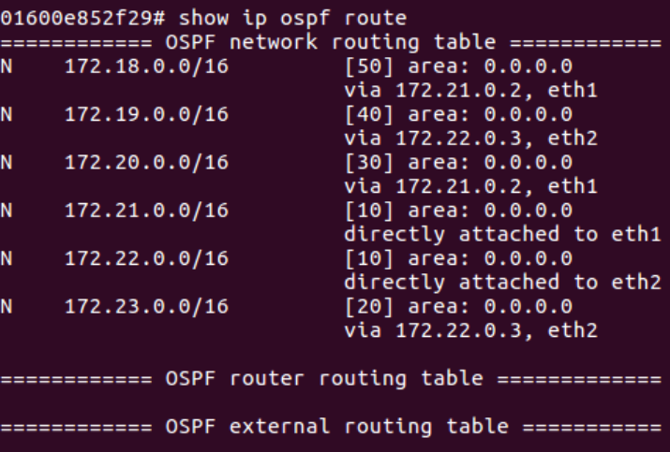

ip routes:

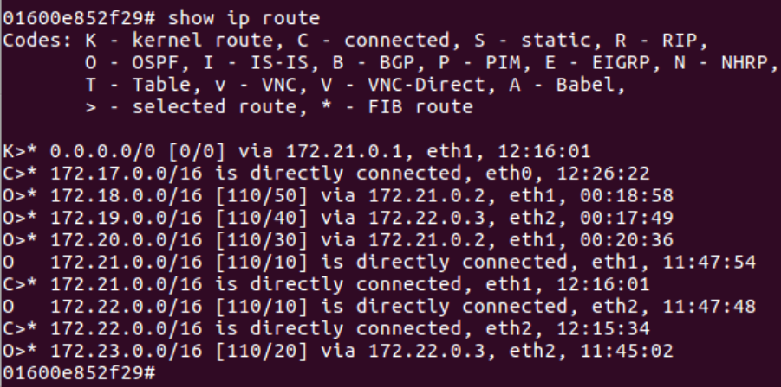

FRR5:

show ospf neighbor:

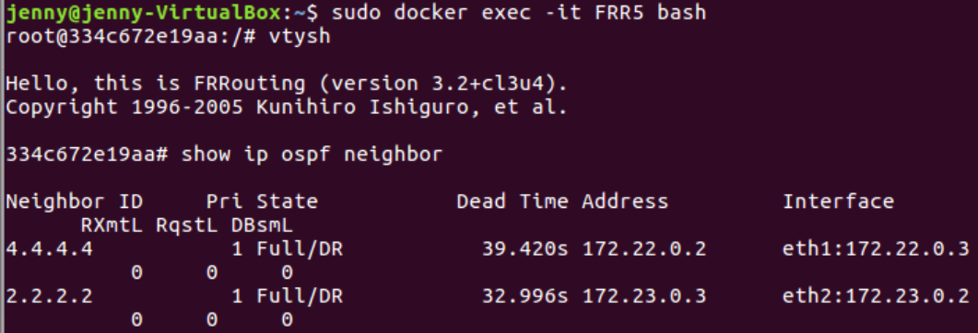

ospf routes:

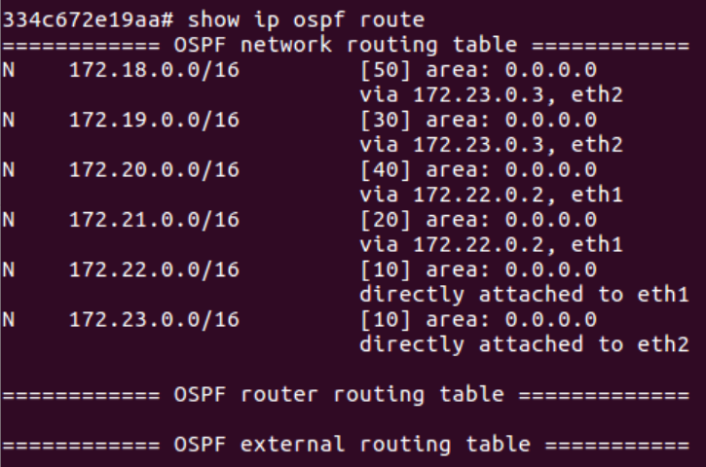

ip routes:

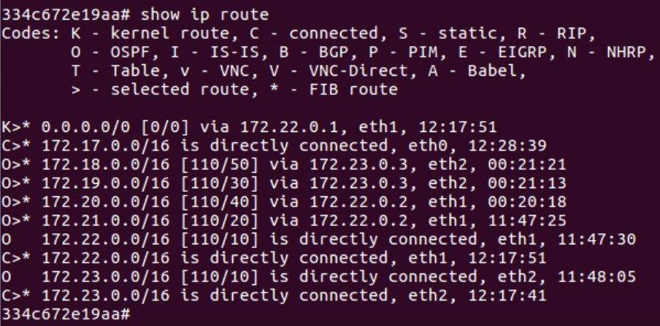

R1 ping R2:

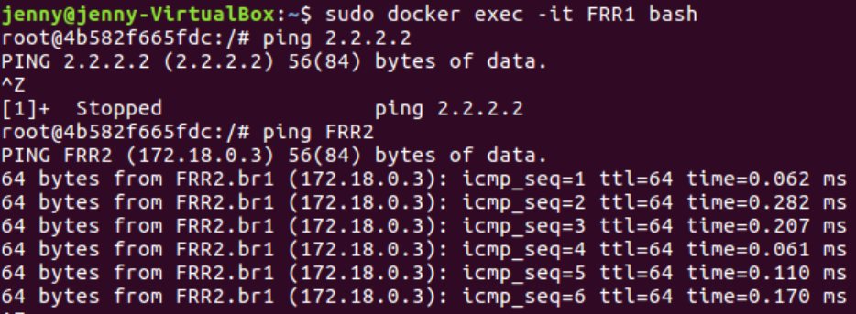

R4 ping R2:

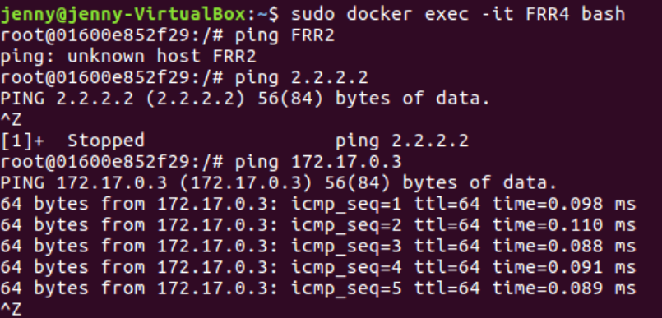

TASK3

**1. Please attach the screenshots where you find the packets are re-routed after each disconnection**

**2.  Please briefly explain how you observe the packets are re-routed, what’s the signature of packet rerouting?**

**3.  Please briefly explain why the packets are taking the new route you observed after each disconnection**

Here we show the wireshark result of task3-part3

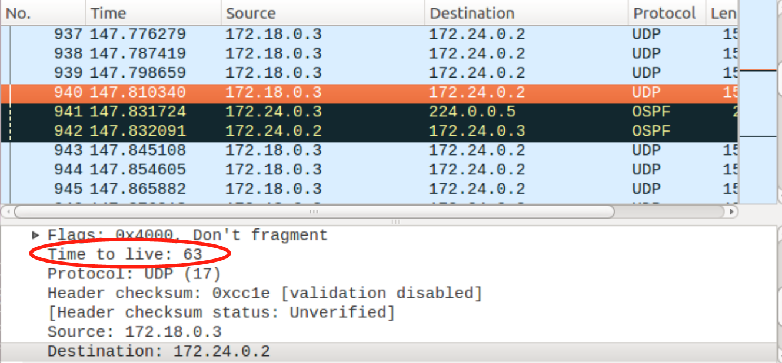

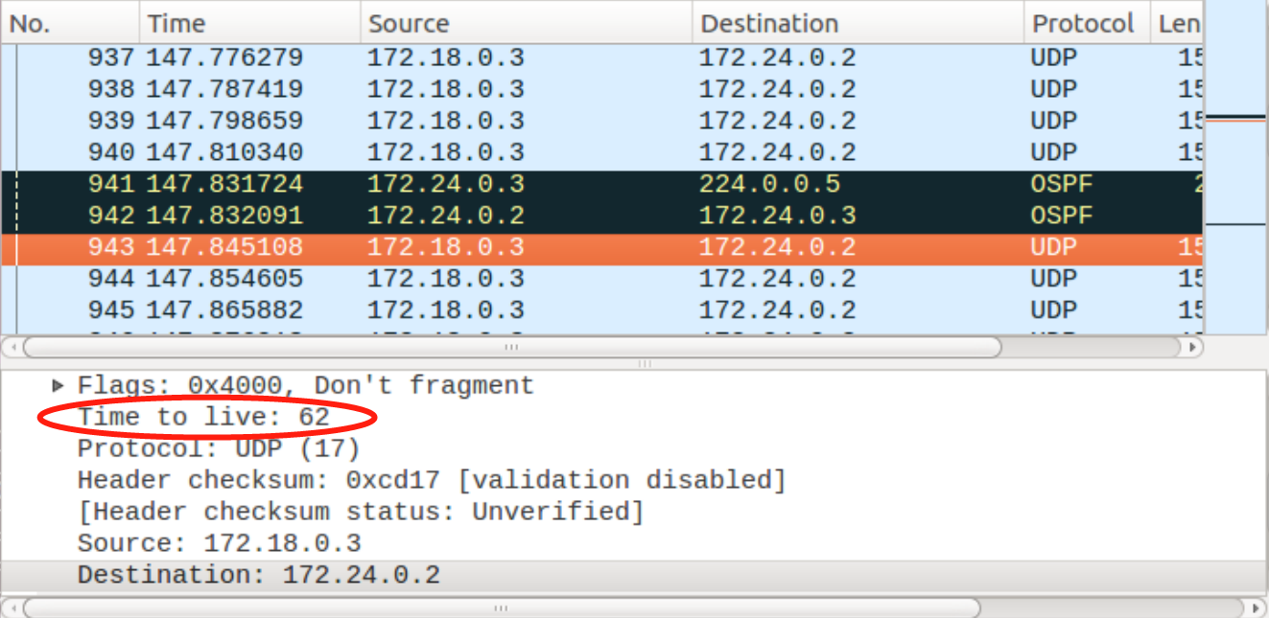

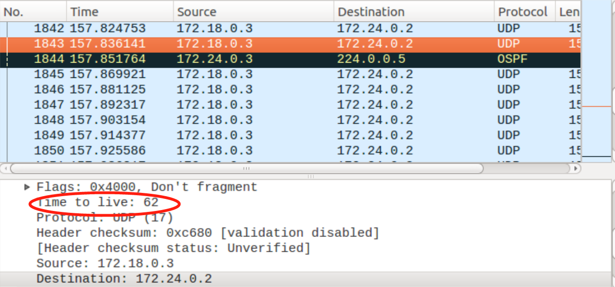

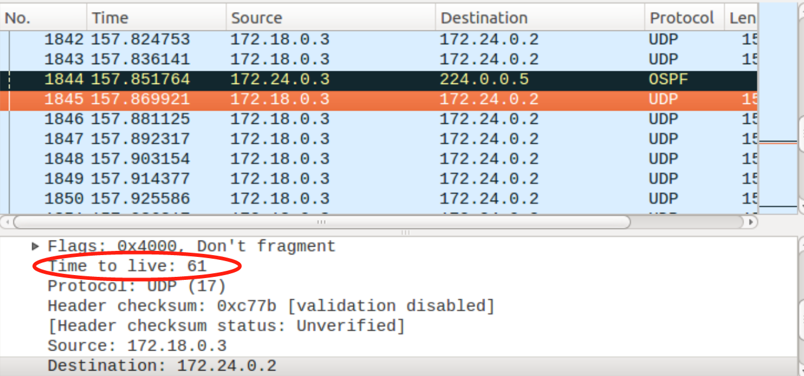

1. Can we find the packet path by Wireshark?

- Yes we can. We can find the packet path by calculating the TTL (Time to live) to find different path the packet took.

2. Which is shorter, the server response time, or the time stamp gap we could notice in Wireshark?

- The response time is shorter, because the Wireshark record happened after the router had restored the packet.